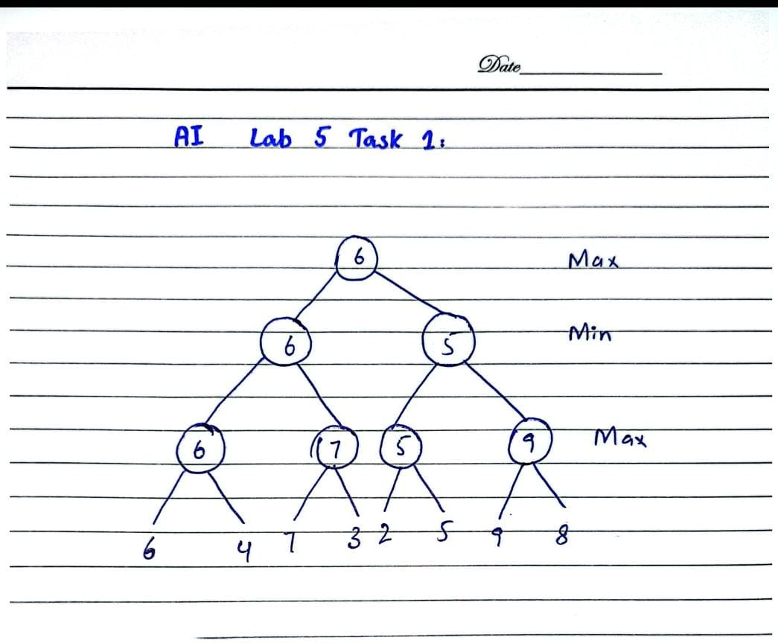
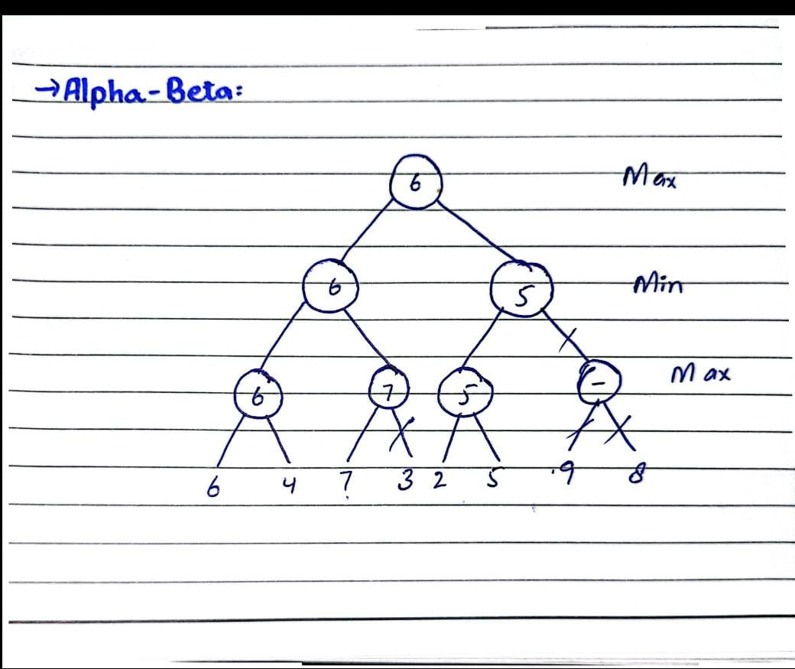
MinMax Code Output:
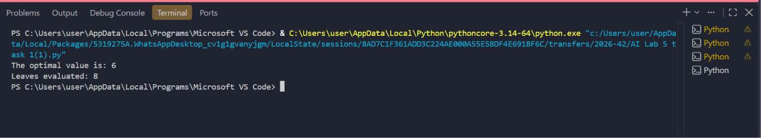

Alpha-beta Code Output:
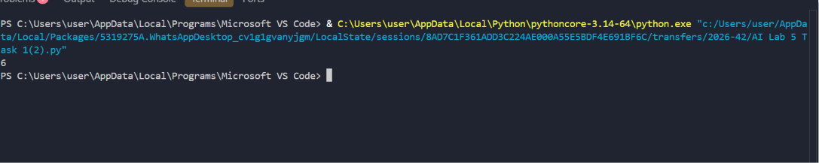
Comparison:
- Minmax note all the 8 leaves while Alpha-beta note only 5 leaves in left to right order.
- In both minmax and alpha-beta root the optimal value is same 6.

